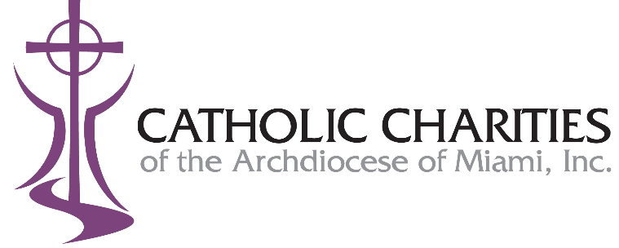

The Services for the Elderly program has been awarded $10,000 in funding support from Greater Miami Jewish Federation. The award is being used to incorporate a person-centered, trauma informed care approach to the services provided to older adults in the communities we serve.
As a result of the many changes resulting from the current Covid pandemic, many older adults were isolated for an extended period of time. Many of these consumers are still hesitant to return to socializing and congregating for meals. To ensure that these isolated older adults are safe and that their needs are still being met, our staff have been making telephone visitation calls to clients enrolled in the program. During these telephone calls, staff provide the much-needed social contact, together with taking the opportunity for identification of emerging unmet needs with the goal of reducing the many risks associated with social isolation.
Catholic Charities staff received training on person-centered, trauma informed care. This care approach will be utilized during the telephone visitation calls to improve quality of care by reducing the triggers and the risk of re-traumatization.
Based on past program experience gained as part of our pandemic response, the expectation is that the staff will be successful in improving quality of care through the provision of telephone visitation calls. Eliminating trauma triggers during staff-client interactions will positively impact the physical, mental, and cognitive health of the older adults we serve. Ultimately supporting the Services for the Elderly goal of maintaining independent living and delaying institutionalization.
The program anticipates providing PCTI via telephone visitation calls or face-to-face meetings to over 700 clients in a 12-month period.

